**Batch: ETRX D2 Roll No.: 16010221038**

**Name: Eshan Kalp Trivedi**

**Experiment / assignment / tutorial No. 10**

**Grade: AA / AB / BB / BC / CC / CD /DD**

**TITLE:**  Application oriented program: Find impedance of series and parallel RLC Circuit

**AIM:** Program to find unknown impedance of RLC circuit and represent the result in both polar and rectangular coordinate system

**______________________________________________________________________ Expected OUTCOME of Experiment:**

1. Formulate a problem statement and develop the logic (algorithm/ flowchart) for its solution
2. Apply basic concepts of C Programming for problem solving
3. Illustrate the derived and structured data types such as arrays, strings, structures, and unions.
4. Design modular programs using functions and demonstrate the concept of pointers and file handling.

**_____________________________________________________________________ Books/ Journals/ Websites referred:**

1. Programming in C, second edition, Pradeep Dey and Manas Ghosh, Oxford University Press.
2. Programming in ANSI C, fifth edition, E Balagurusamy, Tata McGraw Hill.
3. Introduction to programming and problem solving , G. Michael

Schneider ,Wiley India edition.

**_____________________________________________________________________ Problem Definition:**

For a given RLC Circuit and frequency, find the impedance of individual components. Use the formula to calculate total impedance of the circuit, first for series, and next for parallel RLC circuit. Now change the frequency in steps, tabulate the result and comment on the impedance value.

**For Series R-L-**

C

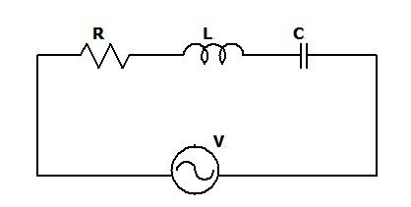

Z

If XL > XC where *XL* = *ωL*, *XC* = 1/*ωC* *and* *ω* = 2*πf*

*Z* = *R*2 + (*XL* − *XC*)2 Ω

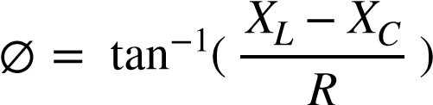

*ZT* = *Z* ∠∅

*ZT* = *R* + *j*(*XL* − *XC*) Ω

**For Parallel R-L-C (R, L and C connected in parallel)**

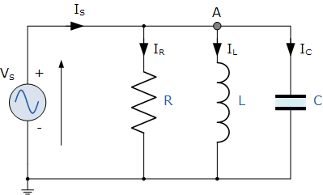

*YR* = *R*1 , *YL* = *w*1*L*, *YC* = wC

*Z* = 1

# YR2 + (YL − YC)2

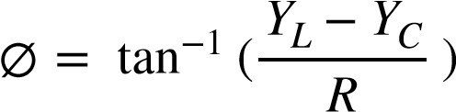

**Implementation details:**

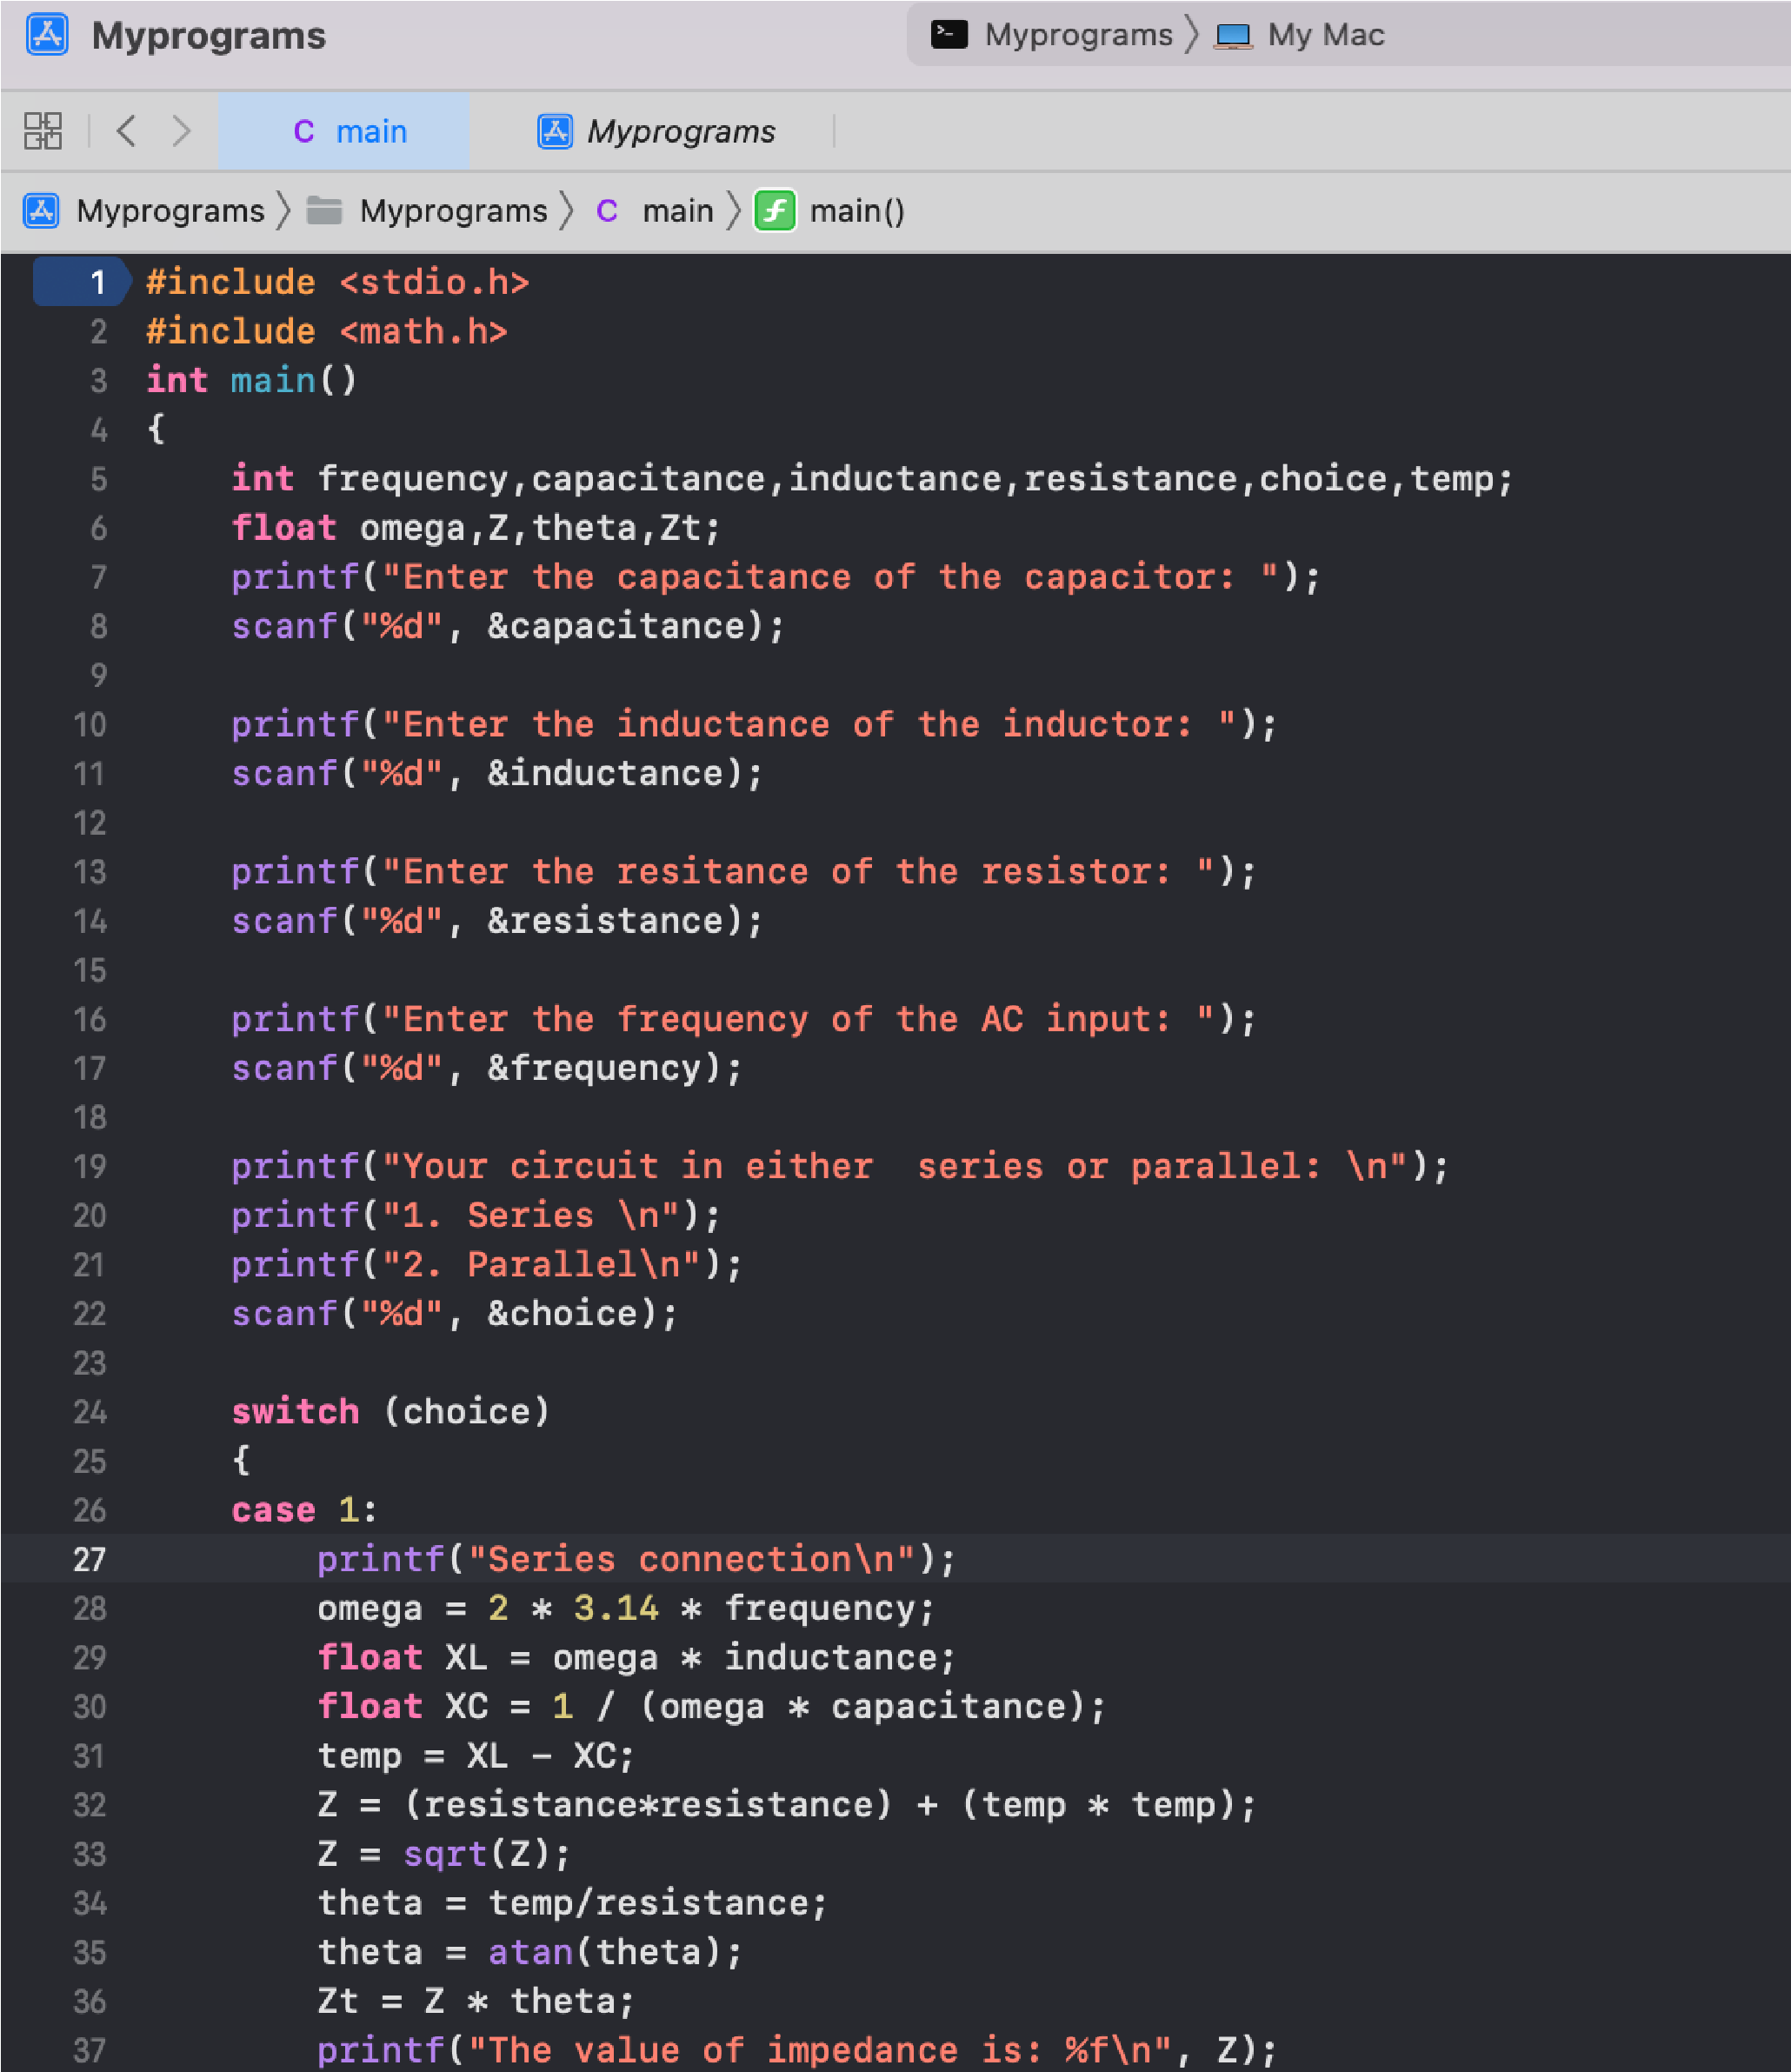

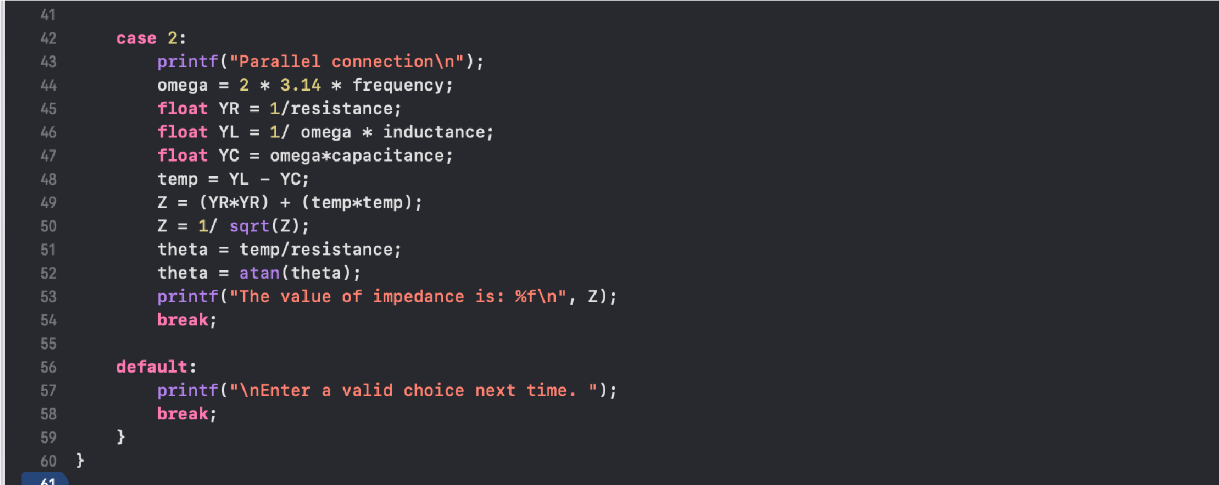

**Output(s):**

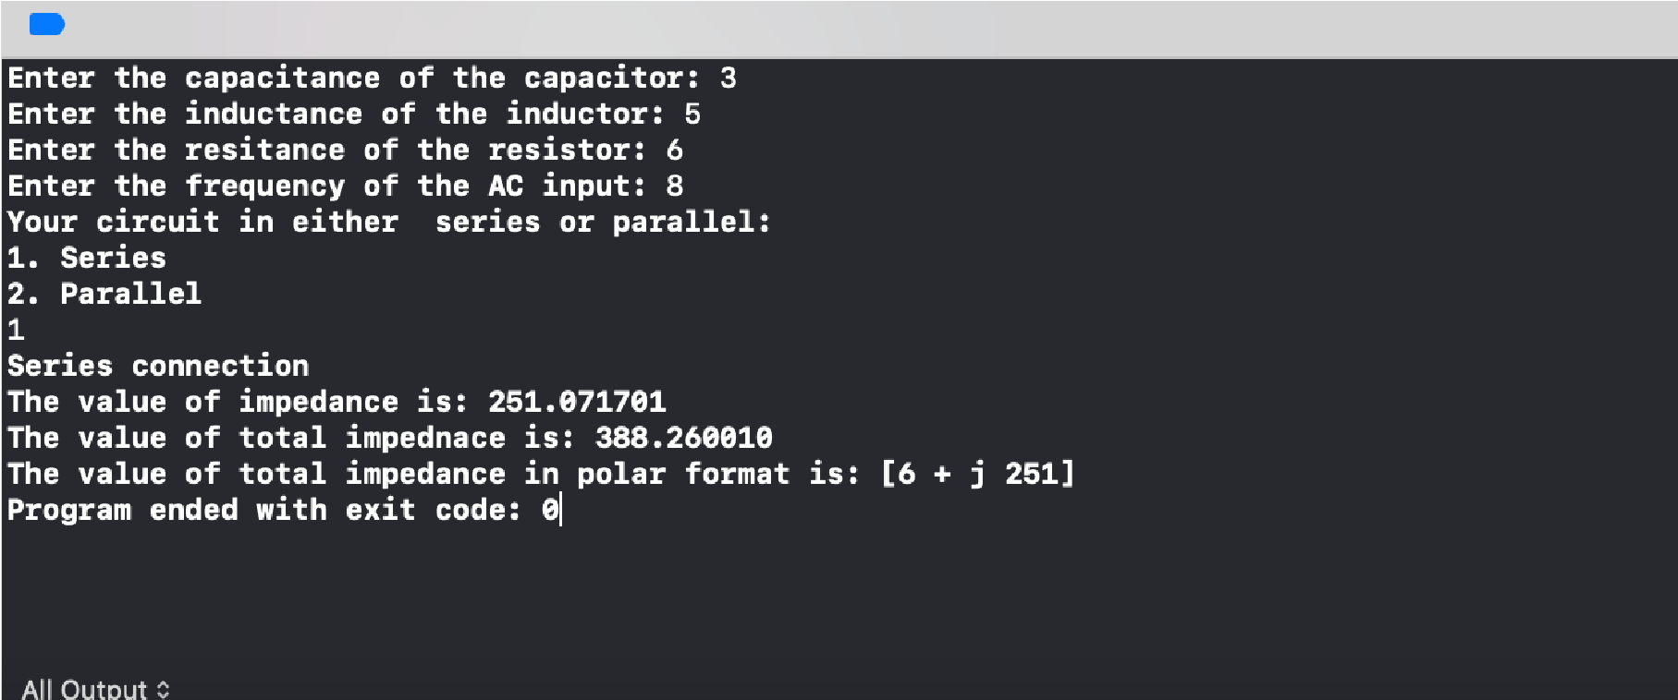

**Conclusion:**

**Program is running with zero errors and optimum output is obtained.**

**Post Lab Descriptive Questions**

**Change the above program to find the following quantities.**

1. **pf =** *coscos* ∅
2. **Active power** *VI* *coscos* ∅
3. **Reactive power** *VI* *sinsin* ∅

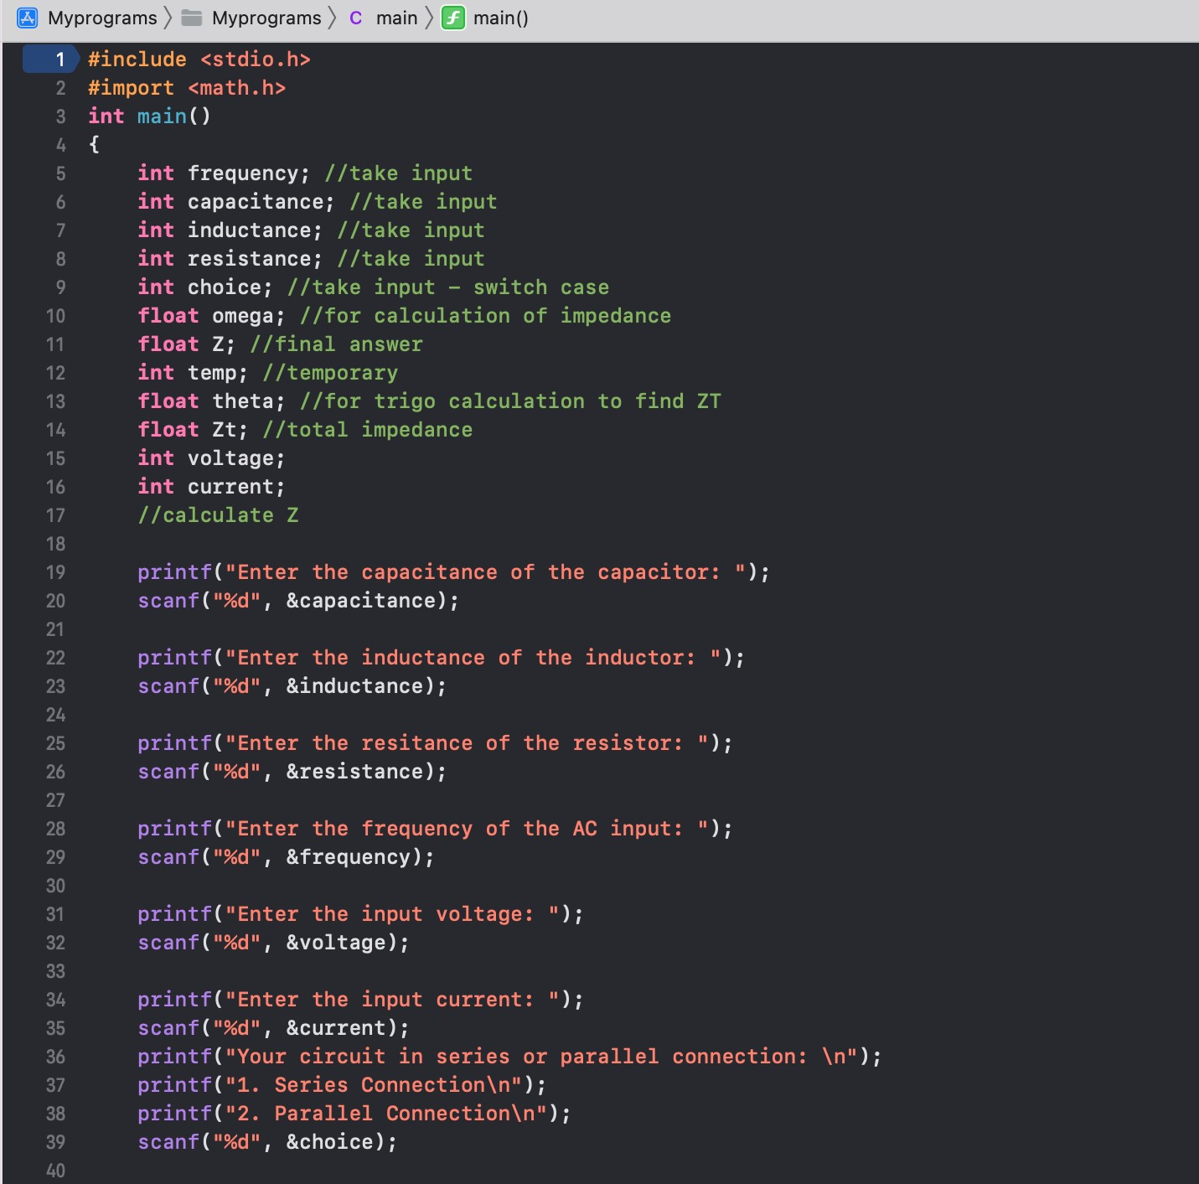

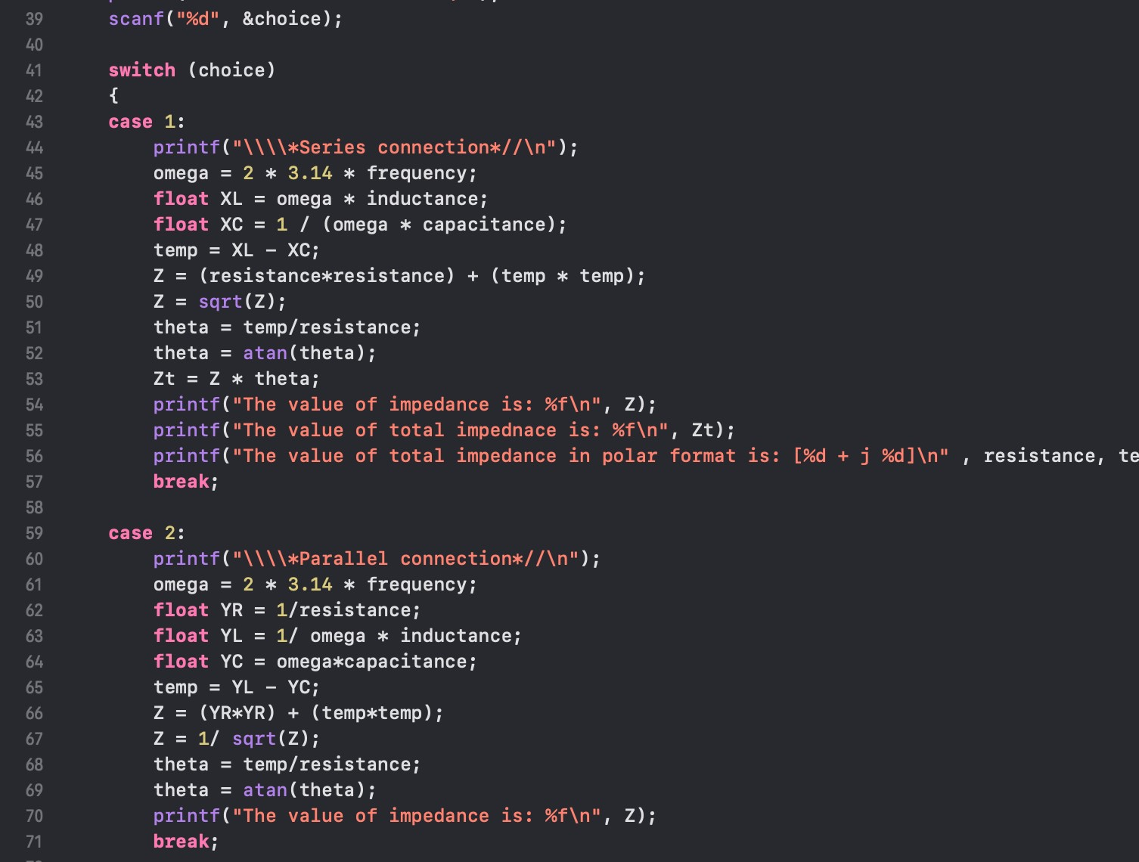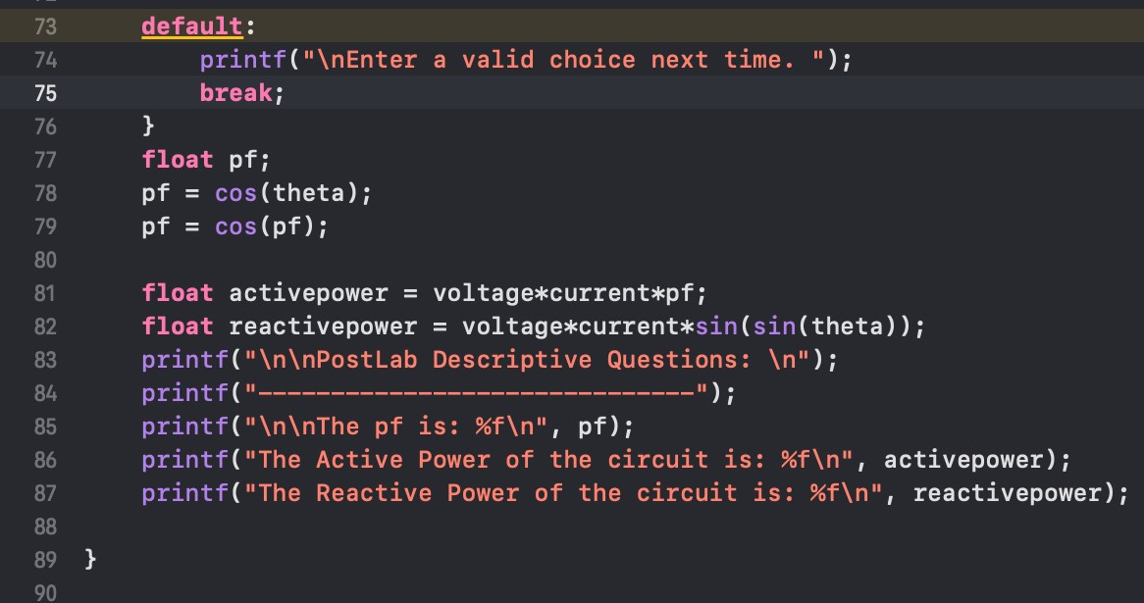

**Output-**

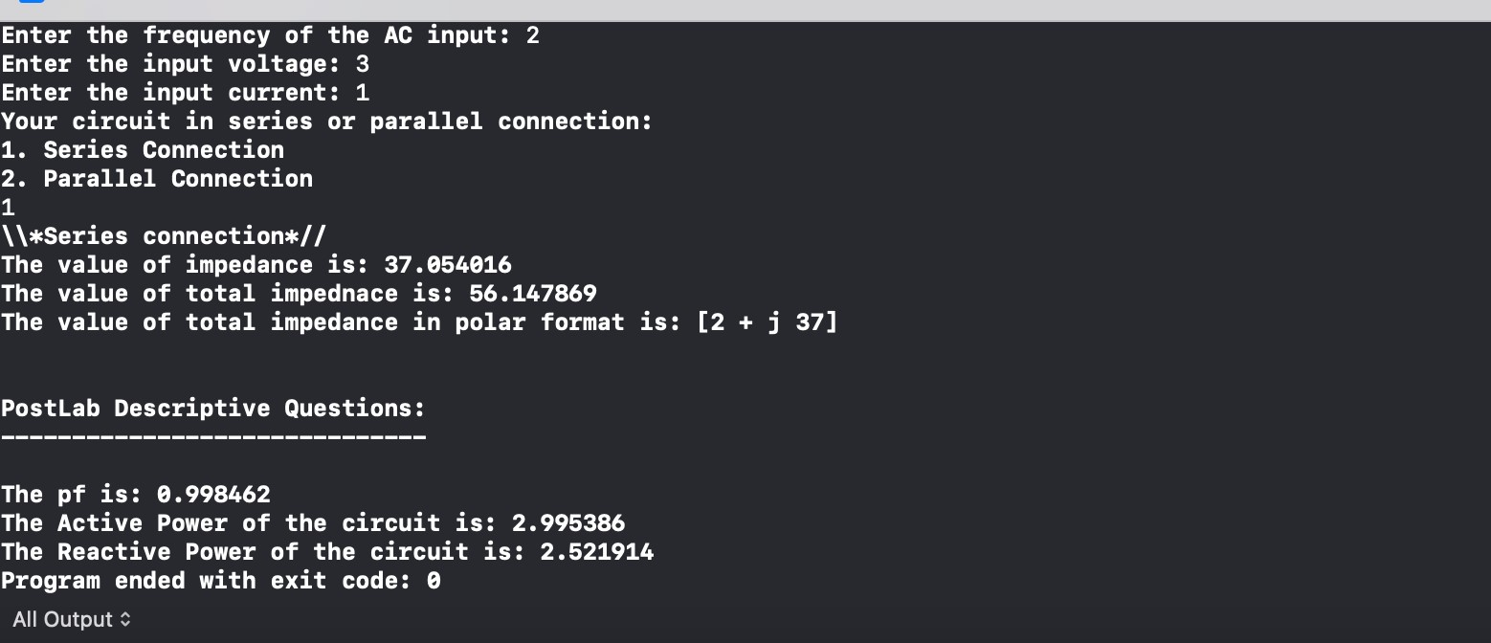

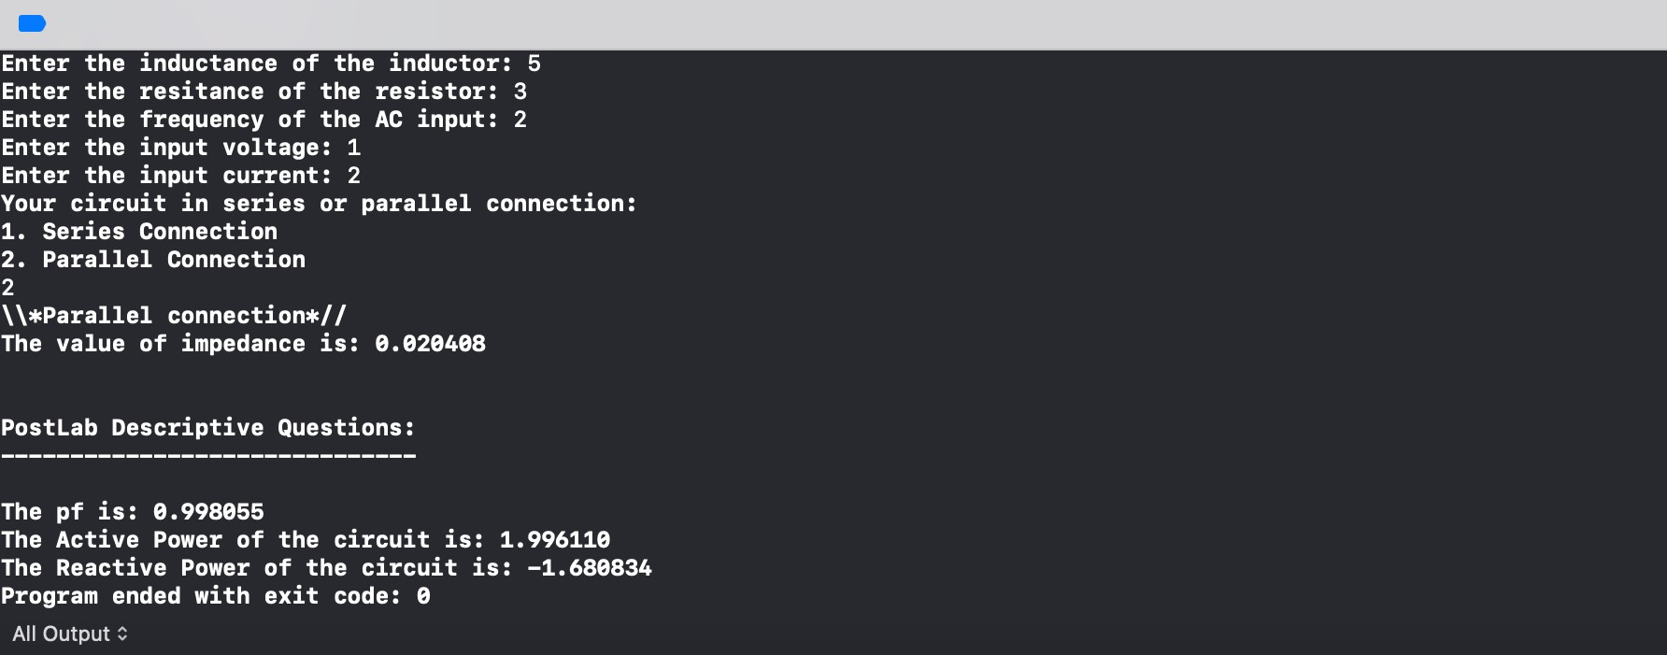

**Date: _____________ Signature of faculty in-charge**